Today, Trump signed into law a massive $1.3 trillion spending bill that will fund the federal government through the rest of fiscal year 2018, and the deal is quite generous to NASA. Practically all of NASA’s programs get a funding boost, and the space agency even gets money that it didn’t ask for — notably, the funds needed to build a second launch platform for its next big rocket.
The spending bill gives NASA an extra $350 million in 2018 to make the structure, which will be used for future launches of the Space Launch System.

That’s the deep space vehicle the agency has been developing for the last decade. A mobile launch platform is key for the SLS since the structure will transport the rocket to its launch site at Kennedy Space Center in Florida and serve as the base for the vehicle to launch from.
NASA ALREADY HAS A LAUNCH PLATFORM FOR THE SLS IN THE WORKS
NASA already has a launch platform for the SLS in the works. So why did Congress allocate money for a second one, exactly? Because the platform that’s almost complete will only be able to support one — just one — launch of the SLS.
The problem stems from the fact that NASA’s current mobile launch platform wasn’t actually built for the SLS. NASA has been modifying a platform that was originally built for a rocket that never saw the light of day — the Ares 1, a vehicle that was meant to send humans back to the Moon as part of the now-canceled Constellation program. When the Constellation program was replaced with the SLS program in 2011, NASA decided to simply upgrade the mobile launch platform the agency had already built for Ares 1 to support the Space Launch System. The SLS is a much bigger and heavier vehicle than the Ares 1 was going to be, so NASA has had to reinforce the base of the platform, as well as expand it to accommodate the larger size of the rocket and its engines.
But late last year, NASA admitted it had a problem: even after the modifications are complete, the launch platform will only be able to support the very first launch of the SLS — a test launch without any people on board. This mission, called EM-1, will use the smallest planned version of the vehicle, known as Block 1. After that launch, NASA will put crew on a much larger version of the SLS, known as Block 1B. In fact, all future human missions will use the Block 1B version. And this bigger rocket is just too tall and too heavy for the current platform — even with all of its upgrades.
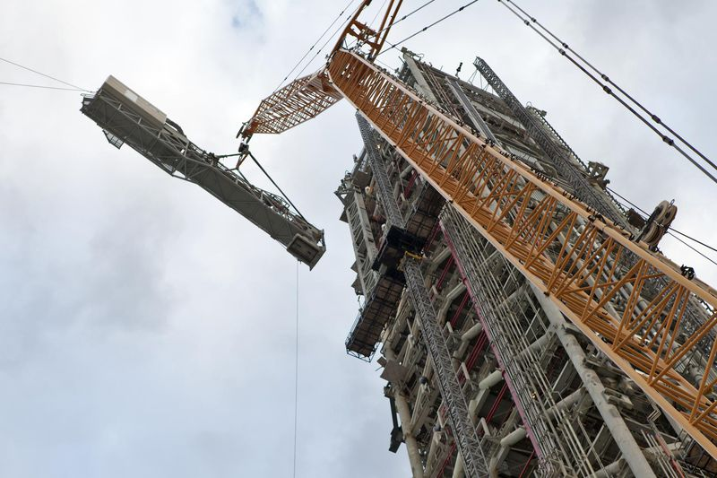
So NASA offered two choices. The first option was simple: the agency could start building another mobile launch platform now to support the larger SLS launches in the future. But that meant the current platform would really only be used once and then essentially tossed aside. The other option was less wasteful: after the first test launch, NASA would upgrade the existing platform again to accommodate future flights. But the next set of upgrades couldn’t begin until the inaugural flight was over.
RELYING ON JUST ONE PLATFORM RISKS DELAYING THE FIRST CREWED FLIGHT OF THE SLS
Relying on just one platform risks delaying the first crewed flight of the SLS. NASA estimated that it would take 33 months to complete the new upgrades, or nearly three years, after the inaugural flight. That would put a huge gap between the first two flights of the rocket, one that could grow if the platform upgrades aren’t finished on time.
Despite the risk, NASA ultimately decided to go with just one platform. The space agency estimated it would need at least $300 million for the project, according to Space News. But the president’s budget request for fiscal year 2019 didn’t include any money for that refurbishment, and NASA’s acting administrator Robert Lightfoot said that it would be too expensive to pursue, according to his testimony during a congressional hearing.
The Crew Access Arm — the passageway astronauts will take to get on the SLS — being installed on the mobile launcher tower. Image: NASA
Now, Congress is telling NASA to build a second platform, likely due to safety concerns. Building the new platform could potentially move the second flight of SLS up to 2022 instead of 2023. Otherwise, having such a huge gap between the first and second flight of the rocket could cause engineers to forget the valuable experience they gained from flying the rocket the first time. “When that happens, you have all the people — in your ground systems and in mission control — you have them sitting around for months at a time with nothing to do,” Casey Dreier, director of space policy at the Planetary Society, tells The Verge. “And in the absence of real rocket launches, you might lose good people.”
But another unofficial motivation could be optics. Further delays would be a bad look for the perennially delayed SLS program. The first flight of the SLS has been consistently pushed back — from 2018, to 2019, and then to 2020. And even when the first two flights of the vehicle are done, the rocket will probably only launch once a year. Many of the biggest supporters of SLS are in Congress — notably the lawmakers from Alabama, where the rocket is being built — and they don’t want any more delays that critics can exploit. “You have other commercial rockets launching much more frequently,” Laura Forczyk, a space consultant and owner of space research and consulting firm Astralytical, tells The Verge, citing SpaceX’s Falcon rockets. Many critics have proposed canceling the SLS and replacing the rocket with similar commercial options, which might fly more regularly. “But if they can lessen that time between [the first two test flights], that will mitigate the criticism they’re getting,” says Forczyk.
“IF THEY CAN LESSEN THAT TIME BETWEEN [THE FIRST TWO TEST FLIGHTS], THAT WILL MITIGATE THE CRITICISM THEY’RE GETTING.”
Still, it’s not a good look to scrap a barely used mobile launch platform. As of now, there are no plans to fly the smaller version of the SLS after the first test flight. A second platform could give NASA the option to fly the smaller version of the SLS again if needed, Dreier argues. But if that doesn’t happen, it means that NASA has taken about a decade and spent upwards of $700 million to build and upgrade a platform that will essentially be thrown away. (In addition to those concerns, it turns out the tower on the platform is slightly leaning, too, though NASA says it won’t affect any launches from the structure.)
“It’s a good reminder why this idea of using [existing] hardware and adapting it to new needs never actually saves you money,” says Dreier. “It just gets spread out over time. When you have to adapt something that has to work in an extreme environment, you have to deal with a lot of unplanned details to make it safe and dependable.”
This whole saga is also a good reminder that Congress will always get the SLS program what it needs — sometimes over even the president's wishes. The rocket has often received money that NASA has requested for the vehicle’s development, and now the SLS is getting even more hardware than it really needs. “To look at the motivations and the opinions behind Congress, you look at the funding,” Forcyzk says. “And they are completely supportive of it in the fact that they always give as much or more than what is requested.”

